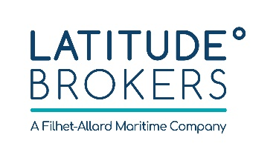
Latitude Brokers brings a fresh new perspective to marine insurance broking in Asia. We combine significant experience in the Shipping and Offshore industries with an energetic, passionate and client-focused approach.
We are headquartered in Hong Kong and part of a global network of companies. Latitude Brokers provide marine insurance solutions to Asia-Pac as well as worldwide-based Clients. We consider each client as unique and our service reflects that.
We offer an open working environment; we value communication, personal responsibility and work-life balance.
Latitude is looking for a resourceful and dynamic Personal Assistant to support the Managing Directors.

Part-time Personal Assistant
Responsibilities
As a Personal Assistant you will be:
- Scheduling and booking trips;
- Managing emails and to-do lists;
- Organizing Sharepoint Drive and Shared Drive
- Preparing business presentations
- Planning events re venue, guests list, invitation etc
- Generally providing support to the Managing Directors in Hong Kong
Profile
- 5 years as a Personal Assistant
- Proficient command of written and verbal English is a must
- Organised, problem-solving and independent
- Computer literate, proficient in MS Office Apps and Outlook
Offer
- Contract job
- 3- 4 days per week, 12 hours per week maximum
- Salary negotiable
- Working from Home
Please send your full resume to recruit@latitudebrokers.com

